**10 May, 2019**

Dear Mr Mbokochena

Ref: Old equipment disposal request.

As media department we are proposing to dispose 2 of our old unused video cameras for purposes of raising money for livestream equipment. A potential buyer has approached us with interest to purchase one of the camera for US$200. See picture below.

**Panasonic HDC MDH1**

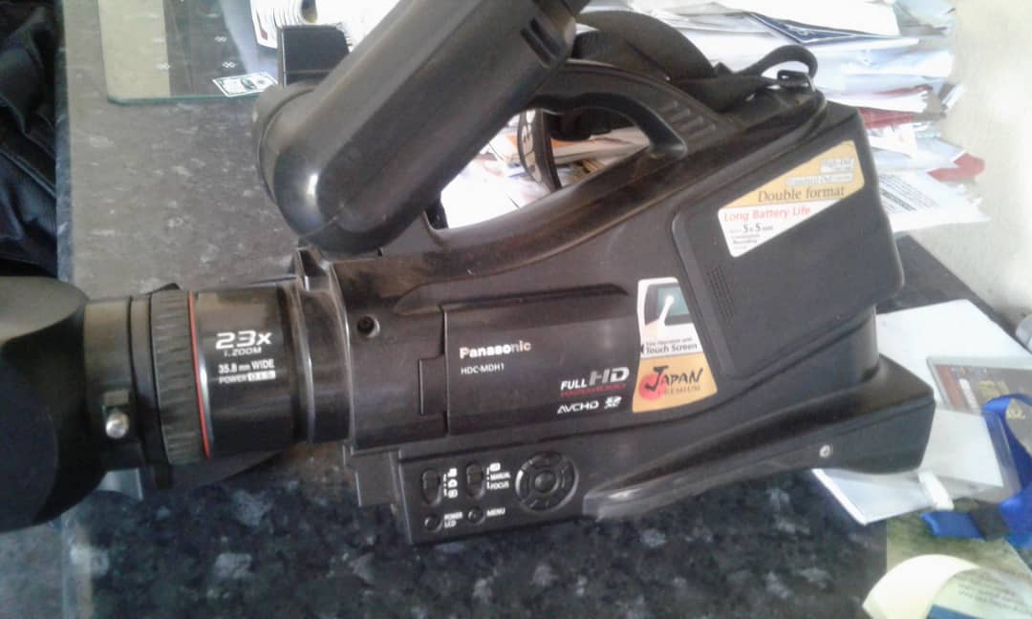

Mutare zone is also interested on another **Panasonic Full HD MDI** and are offering US$300. According to our assessment a fair price will be US$500 but you can try to negotiate and meet them half way maybe US$400 if possible.

Both deals have been put on hold awaiting your office’s approval. Looking forward to your responds.

Best regards,

P.Manyika

Heartfelt Media Deputy Head